https://de.mathworks.com/help/gads/multiobjective-optimization-welded-beam.html
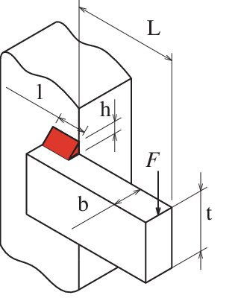
std | worst | mean | Best | Algorithm
0.7296 | 16.2317 | 2.1595 | 1.6743 | world
0.4680 | 10.6306 | 1.9534 | 1.9158 | BBO
0.7282 | 9.1678 | 2.0991 | 1.9738 | DE
0.9815 | 18.0291 | 2.0504 | 1.9384 | FF
0.9859 | 18.1103 | 2.0596 | 1.9471 | GA
0.6308 | 15.4266 | 1.8802 | 1.7701 | HS
0.8726 | 21.3410 | 2.6011 | 2.4488 | IWO
0.9107 | 19.3308 | 2.1618 | 1.9463 | PSO
0.0271 | 3.1024 | 2.4525 | 2.4488 | SA
0.6960 | 10.7459 | 2.5306 | 2.4488 | SFLA
0.8237 | 16.9154 | 2.0110 | 1.9475 | TLBO

Speed reducer Problem

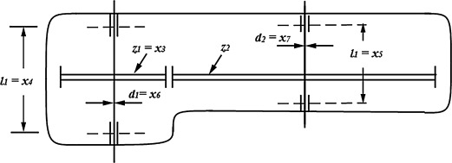
std | worst | mean | Best | Algorithm
1.2146e+03 | 2.7388e+03 | 3.5277e+03 | 2.04e+03 | world
798.5126 | 1.8138e+04 | 3.3330e+03 | 3.13e+03 | BBO
1.2425e+03 | 1.5642e+04 | 3.5815e+03 | 3.36e+03 | DE
1.6746e+03 | 3.0761e+04 | 3.4984e+03 | 3.00e+03 | FF
1.5530e+03 | 2.8527e+04 | 3.2443e+03 | 3.07e+03 | GA
1.0762e+03 | 2.6321e+04 | 3.2081e+03 | 2.63e+03 | HS
1.4888e+03 | 3.6412e+04 | 3.4380e+03 | 3.65e+03 | IWO
1.4552e+03 | 3.0889e+04 | 3.4544e+03 | 3.05e+03 | PSO
46.1597 | 5.2933e+03 | 4.1845e+03 | 3.39e+03 | SA
1.1179e+03 | 1.7260e+04 | 4.0646e+03 | 3.37e+03 | SFLA
0.8237 | 16.9154 | 2.0110 | 2.70e+03 | TLBO

COTEJA

https://ieeexplore.ieee.org/document/8870285

